Name: Mriganka Patra

Email: [mriganka.patra@cognizant.com](mailto:mriganka.patra@cognizant.com)

Emp ID: 2415820

Day 18

Sprint 1 Submission

Objective: Implement the base CRM logic with record types, automation, visibility settings, and user management.

Task 1.7: As a system I want to auto-create an Opportunity when a new Account is added so that sales tracking begins immediately.

1. Go to Setup
3. 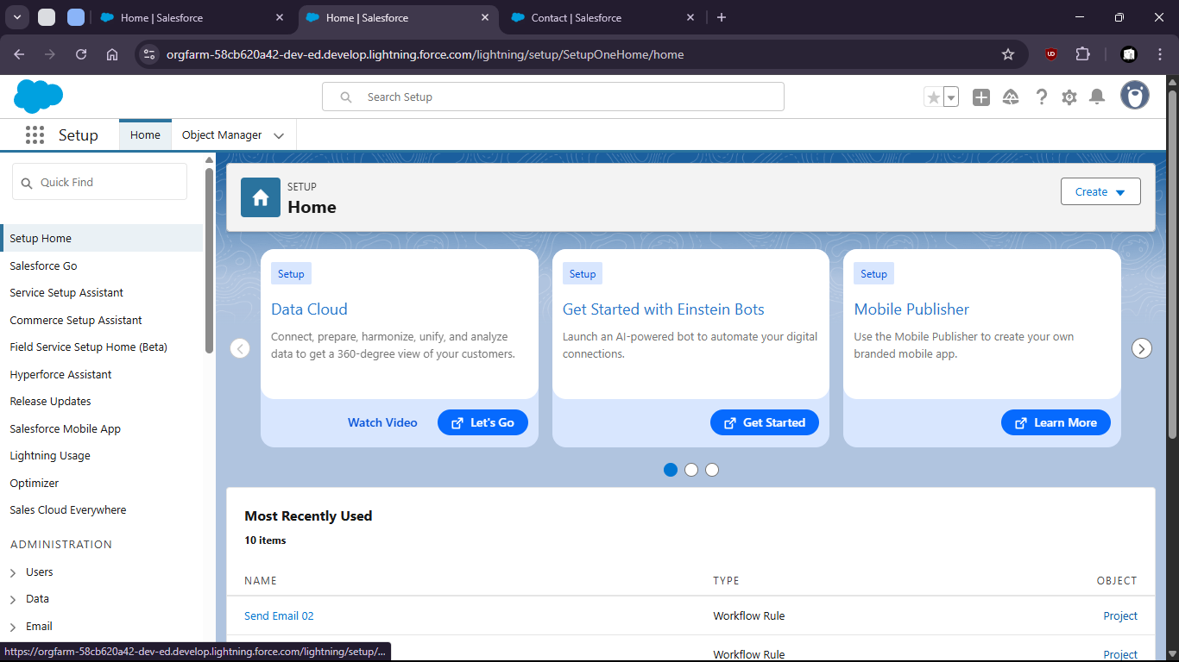
5. Search for “Flows”
7. 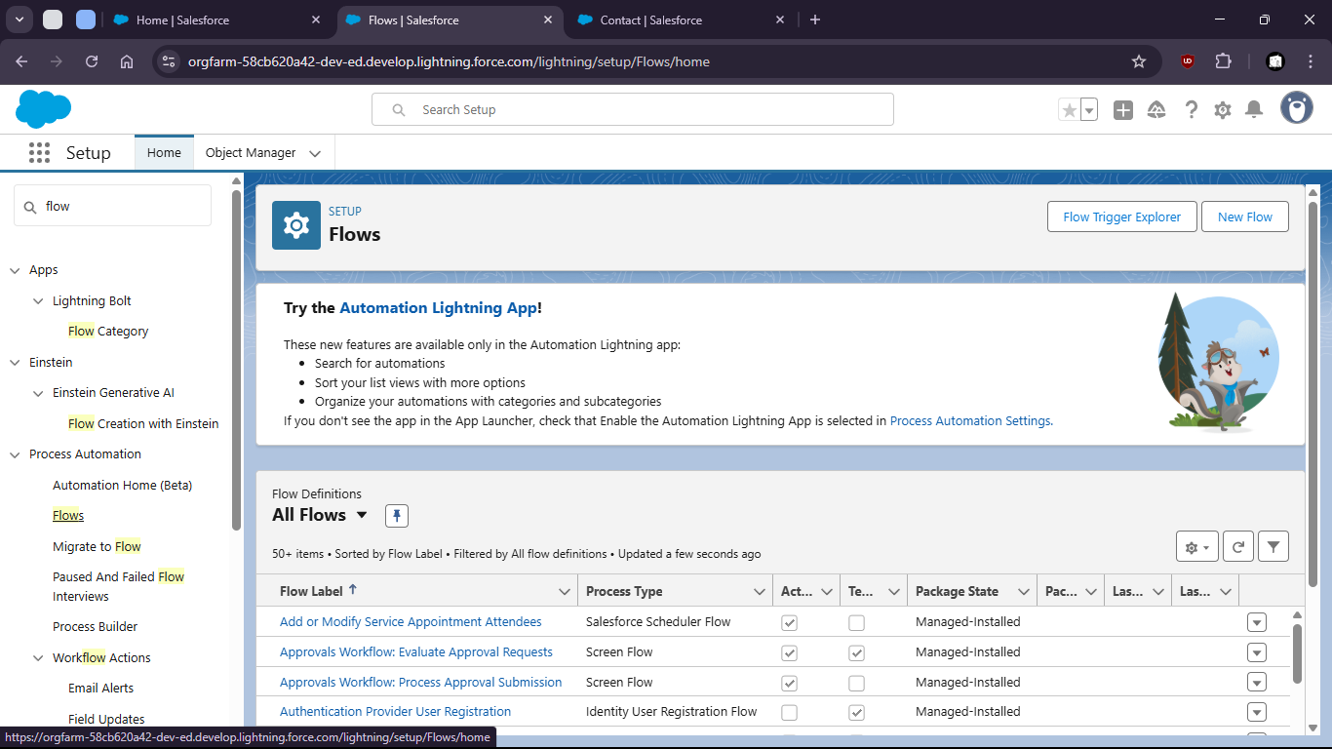
9. Click new
11. 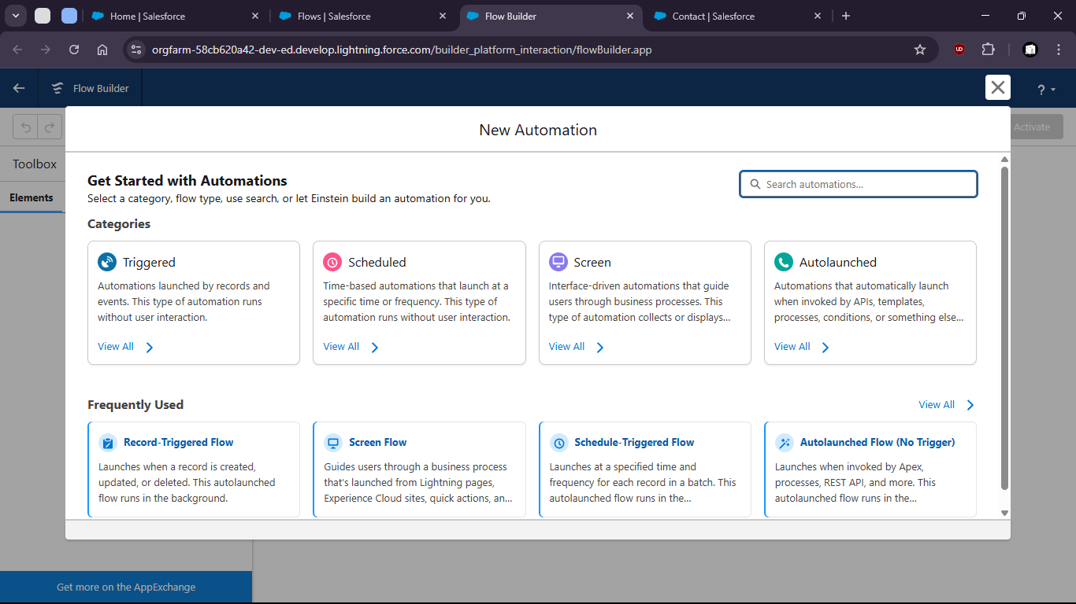
13. Select Record Triggered Flow
15. 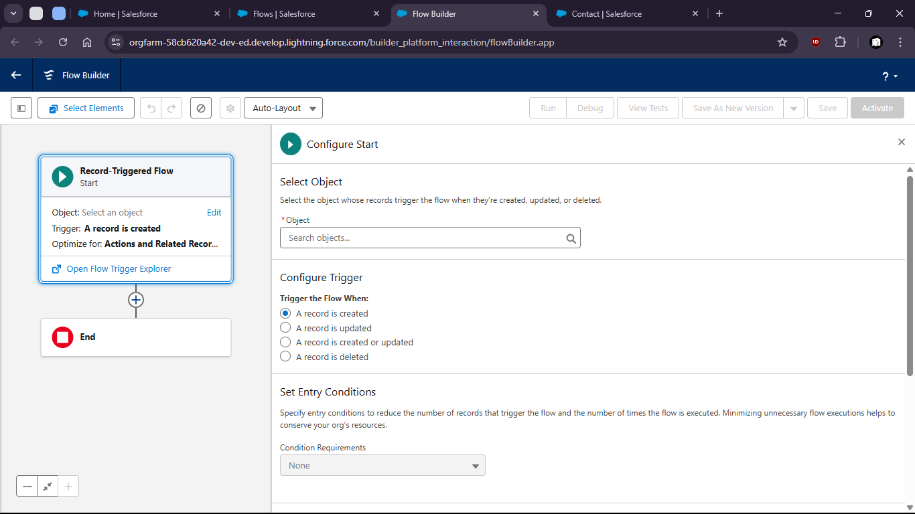
17. Select Account as Object

20. 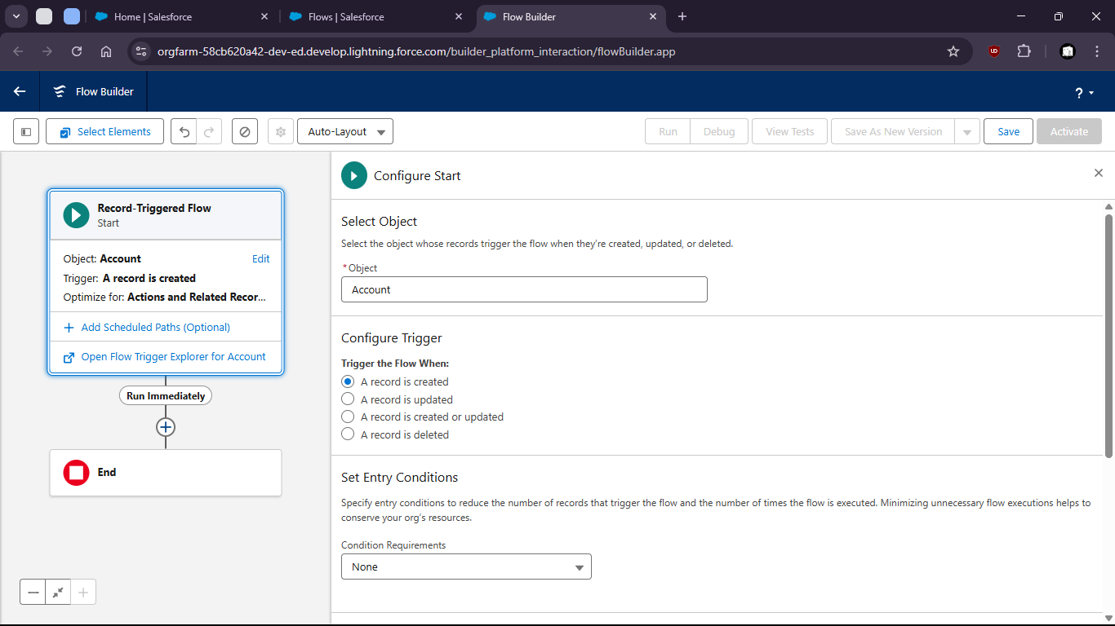

23. Add Create Records Element

26. 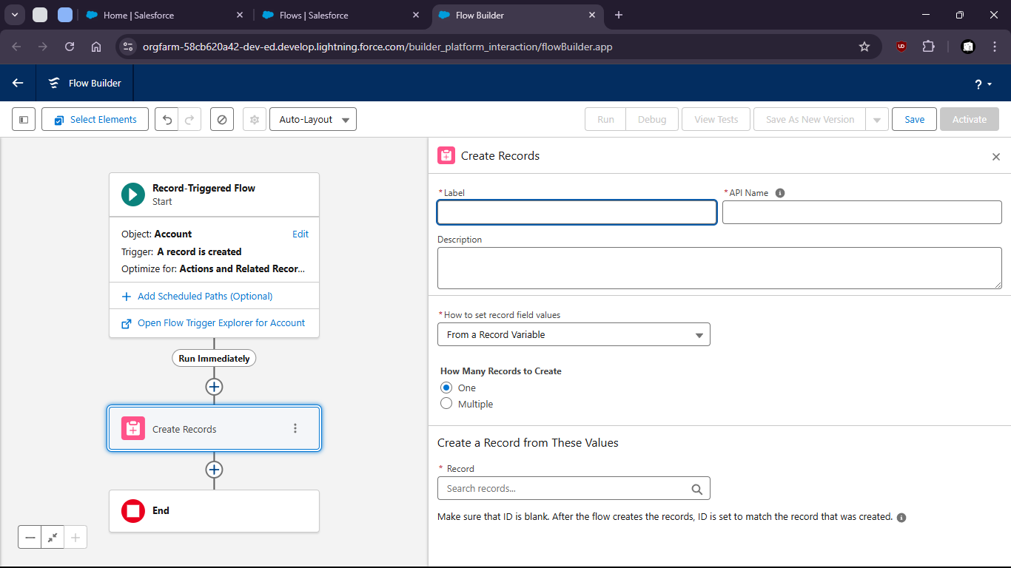


30. Fill Up opportunity field values

33. 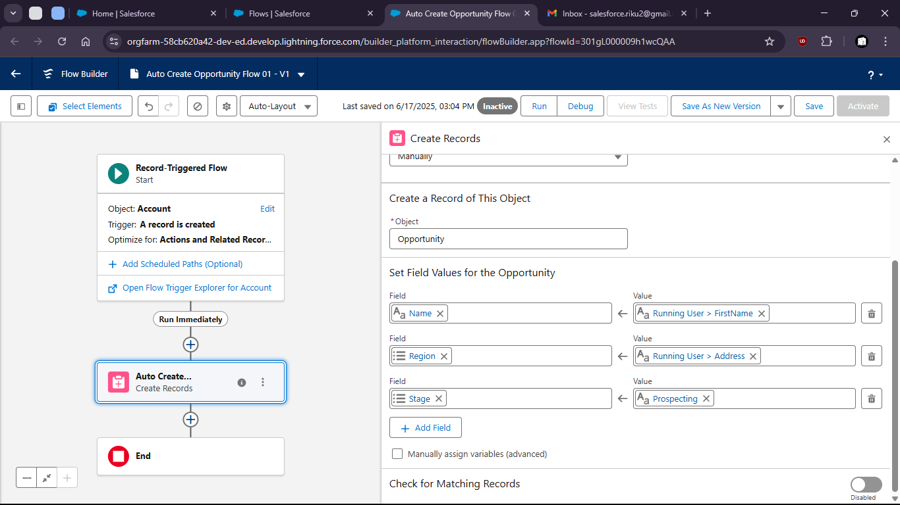

36. Save and Activate

39. 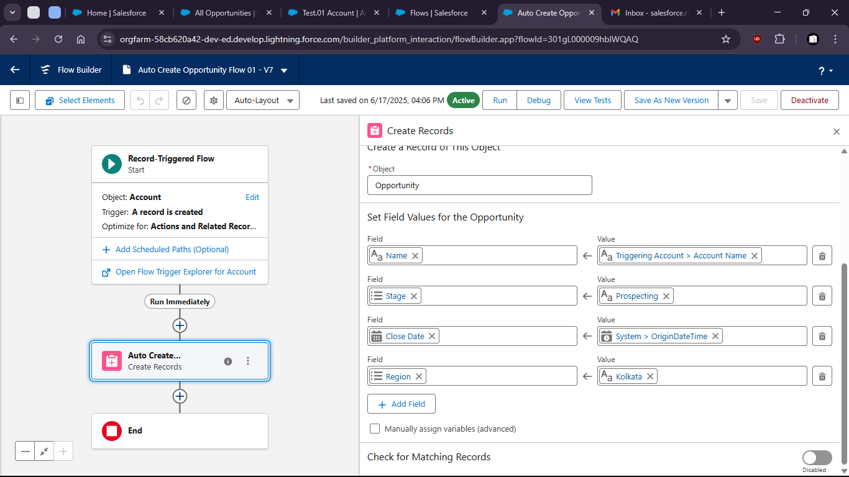

42. Now to verify
43. Crete a new Account (name: Test Account)
45. 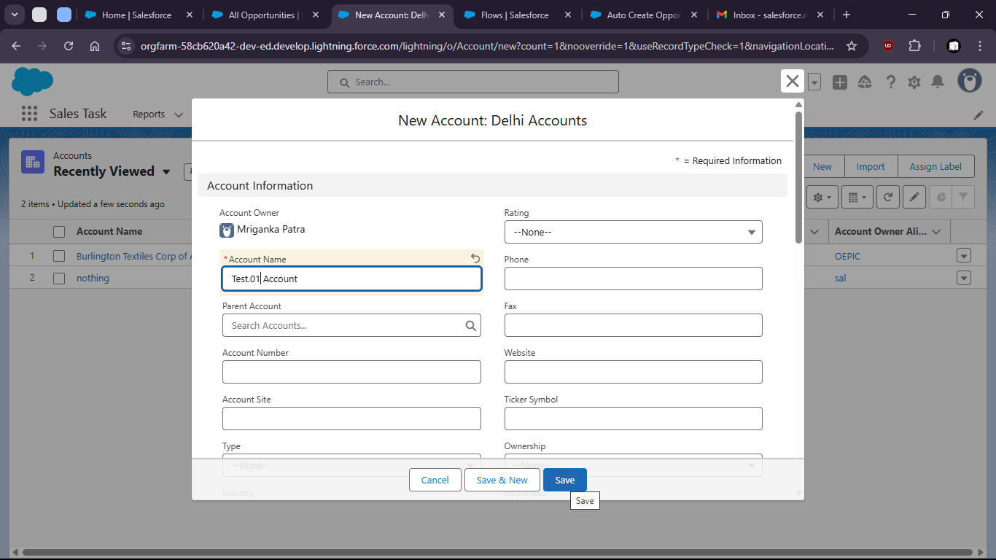

48. 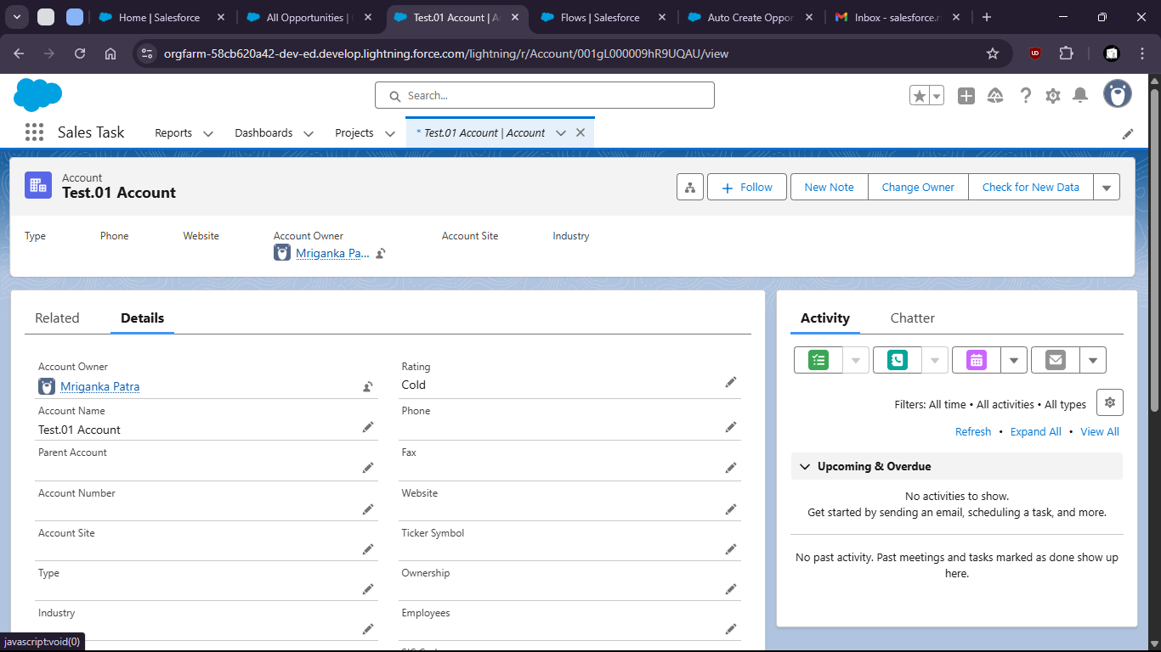
50. We can check new opportunity was created

53. 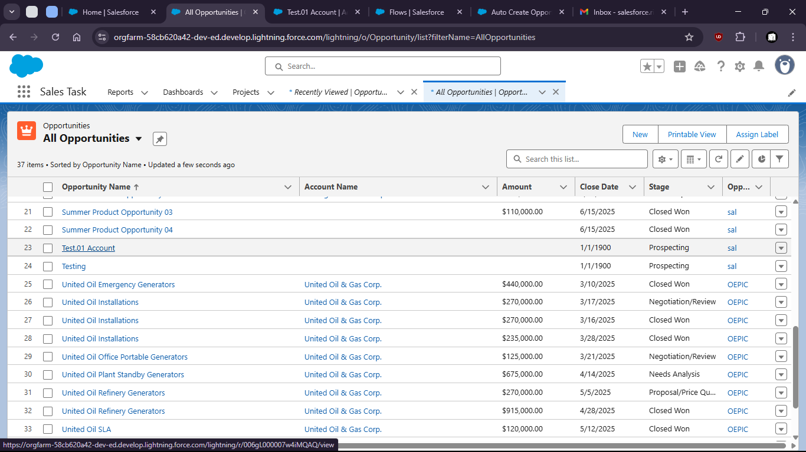

56. 